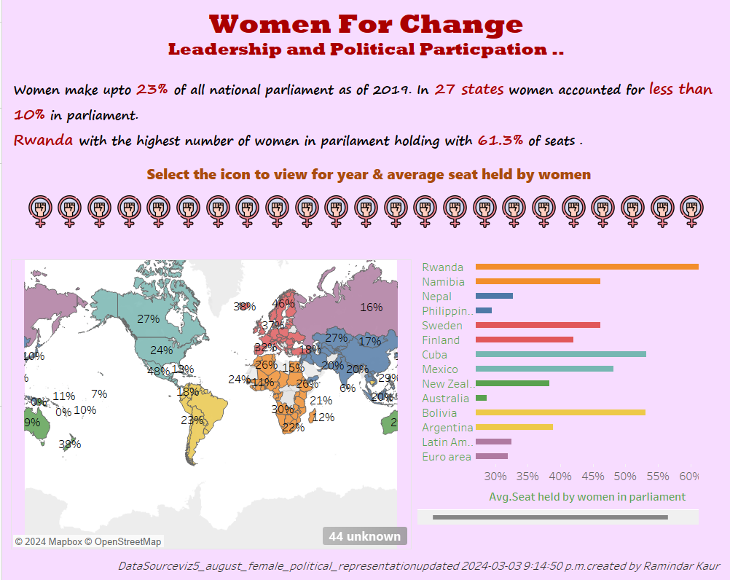

Overview:

The project "Women for Change" aims to raise awareness of extreme gender inequality and catalyze global action to eradicate it. Through a series of data visualizations, the project seeks to educate and inform communities about gender inequality, fostering a collective commitment to building a more equitable world. The current phase of the project concentrates on systemic barriers hindering progress towards gender equality. Specifically, the focus is on assessing the proportion of seats held by women in national parliaments.

Importance of Gender Equality in Leadership:

Active participation of women in leadership and decision-making roles is a pivotal objective within the 2030 Agenda for Sustainable Development. The dataset concentrates on parliamentary participation at the national level. However, it underscores the broader reality that women remain underrepresented across all positions of power - be it elected offices, civil service, private sector leadership, board roles, or academia. A 2011 UN General Assembly Resolution emphasizes the global marginalization of women from the political sphere, attributing it to discriminatory laws, practices, attitudes, gender stereotypes, low education levels, limited healthcare access, and the disproportionate impact of poverty on women.

Call To action:

While some women have overcome these challenges, their success remains a minority in the global political landscape. The project underscores the urgency to create gender-equal and balanced political spaces. The provided facts and figures illustrate the existing gaps and emphasize the imperative need for concerted efforts to achieve lasting change in the realm of gender equality.

Dataset: You can download the dataset

SOURCE ARTICLE: [Proportion of seats held by women in national parliaments](https://data.worldbank.org/indicator/SG.GEN.PARL.ZS)  
DATA SOURCE: [World Bank](http://api.worldbank.org/v2/en/indicator/SG.GEN.PARL.ZS?downloadformat=excel)

Modify the dataset in Tableau:

To prepare and clean the dataset used data interpreter in Tableau. After cleaning we need to modify the data before we use it in tableau. To do this we use pivot in tableau

Create Average Trend:

First I am creating average trend to see percentage of seats held by women in all sic continents.

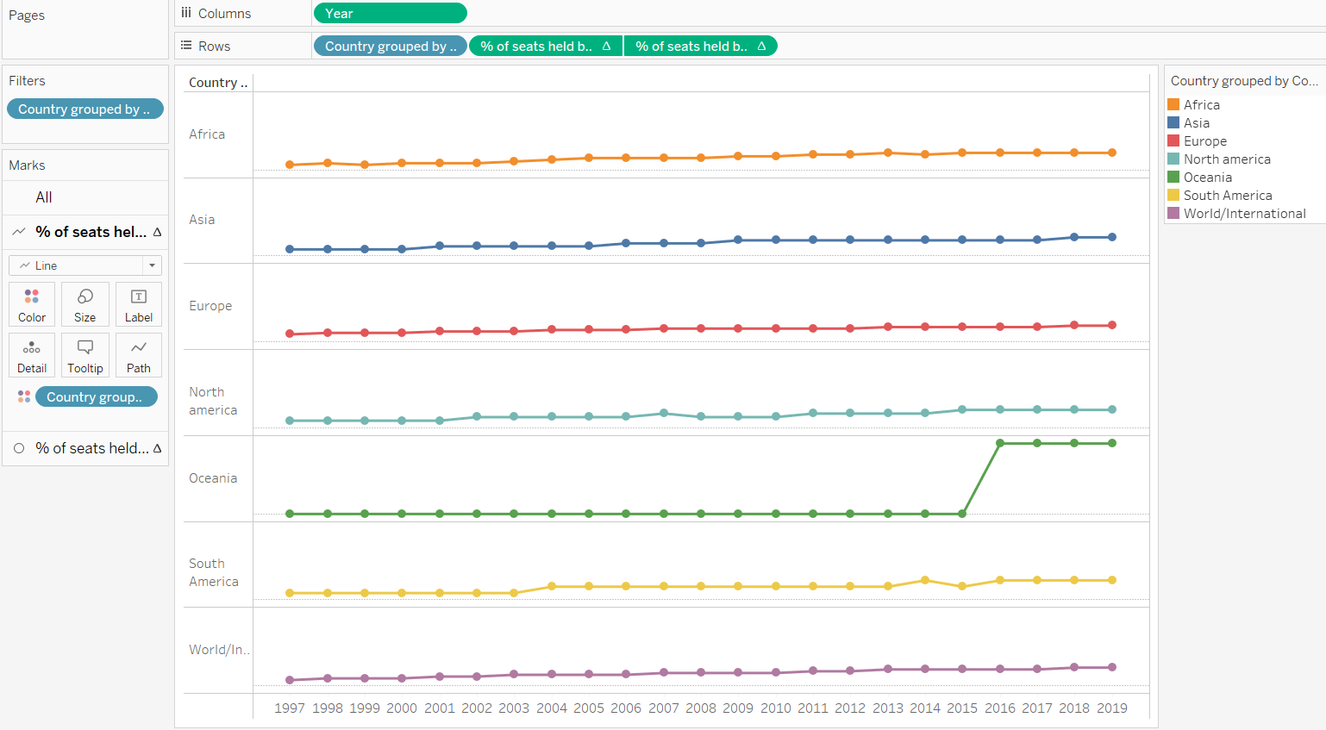

Second I created map and giving color based for six different continent and showing the percentage of women in political leadership. As a filer we can select the year from 1997-2020.

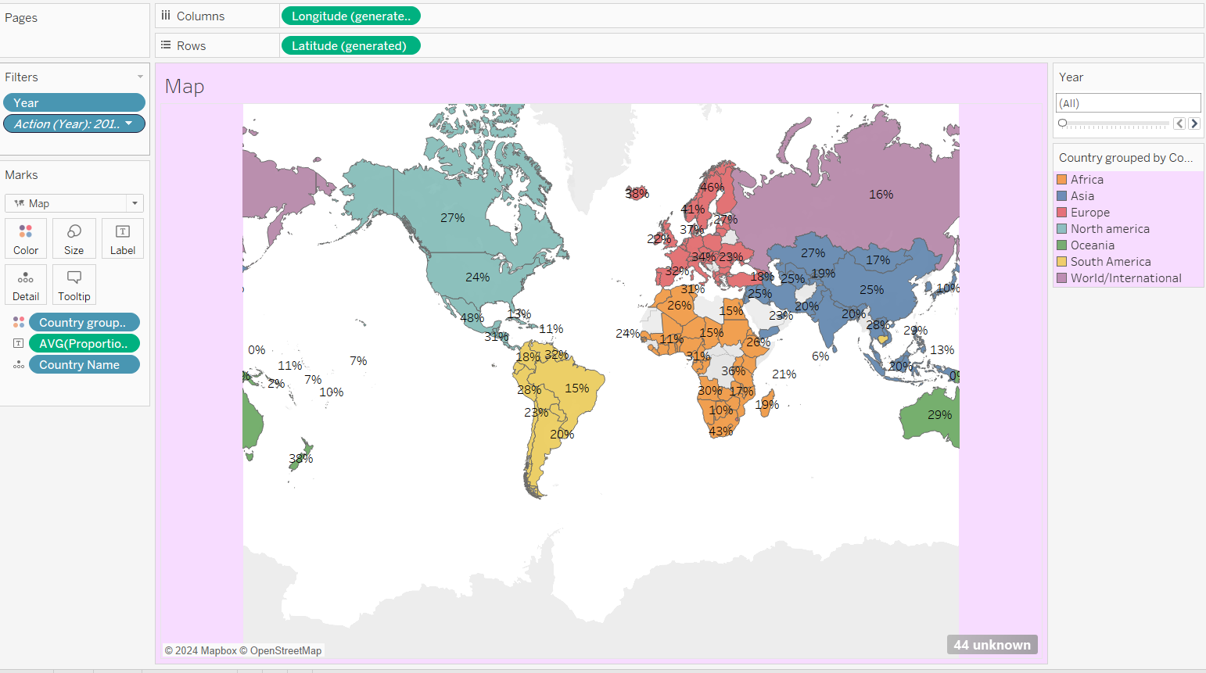

Analysis:

Only 24.3 per cent of all national parliamentarians were women as of February 2019, a slow

increase from 11.3 per cent in 1995.

• As of June 2019, 11 women are serving as Head of State and 12 are serving as Head of

Government.

• Rwanda has the highest number of women parliamentarians, with women making up 61.3 per cent

of seats in the lower house.

• As of February 2019, there are 27 states in which women account for less than 10 per cent of

parliamentarians in single or lower houses, including 3 chambers with no women at all.